## Report on Chatting App 1.1

**by**

Vishal Sen - 2100290140064

**Session:2022-2023 (4th Semester)**

Under the supervision of

## Mr. Akash Rajak (ASSISTANT PROFESSOR)

**KIET Group of Institutions, Delhi-NCR, Ghaziabad**



**DEPARTMENT OF COMPUTER APPLICATIONS KIET GROUP OF INSTITUTIONS, DELHI-NCR,**

**GHAZIABAD-201206**

(MAY- 2024)

The project is a messaging app designed to facilitate communication between users through **text**, **multimedia**, and **group chat**. The app features an intuitive user interface that allows users to easily navigate and interact with the platform. Users can create one-to-one chats and group chats with friends, family, and colleagues, and they can share text messages, photos, videos, and other **multimedia** files.

One of the key features of the app is its multimedia sharing capability, which enables users to share photos, videos, and other media files seamlessly. The app also supports photo editing and filtering, allowing users to customize their pictures before sharing them with others. In addition, the app has a real-time translation feature that helps users overcome language barriers and communicate with people from different parts of the world.

The app provides users with a notification system that keeps them informed about new messages, group chat invitations, and other updates. It also has a search function that allows users to quickly find chats, messages, and media files.

The app is designed with security and privacy in mind, and it includes features such as end-to-end encryption, two-factor authentication, and password protection. The app is compatible with both **Android** and **iOS** platforms, and it is available for free download from the respective app stores.

Overall, the messaging app is a user-friendly, feature-rich, and secure platform that aims to enhance communication and foster connections between people across the globe.

1. Introduction 4
2. Literature Review 5
3. Project / Research Objective 7
4. Research Methodology 8
5. Project / Research Outcome 9
6. Proposed Time Duration 10

References 11

The project is a messaging app designed to provide users with a convenient and user- friendly platform for communication. The app features various tools and features that enable users to send and receive text messages, photos, videos, and other multimedia files with ease. In addition, the app includes group chat functionality, which allows users to create groups and invite friends, family, and colleagues to chat together.

One of the key features of the app is its multimedia sharing capabilities, which enable users to share photos and videos seamlessly. The app includes photo editing and filtering tools that allow users to customize their photos before sharing them with others.

The app also includes a real-time translation feature, which helps users overcome language barriers and communicate with people from different parts of the world. The app provides users with a notification system that keeps them informed about new messages, group chat invitations, and other updates.

Security and privacy are also key considerations in the app's design. The app includes features such as end-to-end encryption, two-factor authentication, and password protection to ensure that users' messages and media files are secure and protected.

The app is designed to be compatible with both Android and iOS platforms, and it is available for free download from the respective app stores. The messaging app aims to provide users with a convenient, secure, and enjoyable platform for communication, fostering connections between people across the globe.

The messaging app market has experienced rapid growth in recent years, with users seeking new and innovative ways to communicate with friends, family, and colleagues. Researchers have identified several key features that users look for in messaging apps, including ease of use, multimedia sharing, group chat functionality, and real-time translation capabilities.

One study published in the Journal of Computer-Mediated Communication found that users value messaging apps that offer rich media sharing capabilities, such as photo and video sharing. The study also highlighted the importance of group chat functionality, which allows users to communicate with multiple people at once.

In recent years, messaging apps have become increasingly popular for personal and professional communication due to their convenience and cost-effectiveness. Research has identified several key factors that influence user satisfaction and adoption of messaging apps, including ease of use, multimedia sharing, group chat functionality, real-time translation capabilities, and security and privacy features.

One study published in the Journal of Computer-Mediated Communication found that users place a high value on messaging apps that offer rich media sharing capabilities, such as photo and video sharing. The study also highlighted the importance of group chat functionality, which allows users to communicate with multiple people at once (Namba & Swar, 2019).

Ease of use is another important factor in messaging app design. A study published in the International Journal of Human-Computer Studies found that users prefer messaging apps that are intuitive and easy to navigate. The study emphasized the importance of app design in promoting user adoption and retention (Huang et al., 2019).

Security and privacy are also critical considerations in messaging app design. A study published in the Proceedings of the 2016 ACM Conference on Computer Supported Cooperative Work and Social Computing found that users prioritize security over convenience when it comes to messaging apps. The study highlighted the importance of features such as end-to-end

encryption and two-factor authentication in promoting user trust and adoption (Matschitsch & Tscheligi, 2016).

Real-time translation capabilities can also enhance the usability and accessibility of messaging apps for users who communicate across languages. A study published in the Journal of Cross-Cultural Psychology found that messaging apps with translation features can help users overcome language barriers and facilitate cross-cultural communication (Matsumoto & Yoo, 2019).

Overall, research suggests that messaging apps that offer a combination of multimedia sharing, group chat functionality, ease of use, security and privacy features, and real-time translation capabilities are likely to be well-received by users. By incorporating these features into the app design, developers can create a messaging app that meets the needs and preferences of a wide range of users.

# PROJECT OBJECTIVE

1. To create a user-friendly messaging app that allows for seamless communication between individuals and groups.
2. To provide multimedia sharing capabilities that enable users to share photos, videos, and other types of media with ease.
3. To ensure the security and privacy of user data through the implementation of features such as end-to-end encryption and two-factor authentication.
4. To integrate real-time translation capabilities that enable users to communicate across different languages and cultures.
5. To provide a customizable interface that allows users to personalize their messaging experience according to their preferences.
6. To ensure the scalability of the app by optimizing its performance and functionality for use by a large number of users.
7. To gather feedback from users and use it to improve the app's features and functionality over time.

# RESEARCH METHODOLOGY

1. **Literature review:** Conduct a comprehensive literature review to gain an understanding of current research and best practices related to messaging app design, user behavior, and preferences. This can help inform the development of your app's features and functionality.
2. **Surveys:** Administer surveys to potential users to gather information on their communication needs, preferences, and concerns. This can help ensure that your app is designed with user needs in mind and can also help identify areas for improvement.
3. **Focus groups:** Conduct focus groups with potential users to gain more in-depth insights into their communication preferences and behaviors. This can also help identify areas for improvement and refine the app's design.
4. **User testing:** Conduct user testing to evaluate the app's usability and identify any bugs or areas for improvement. This can be done through a variety of methods, including alpha and beta testing, A/B testing, and usability testing.
5. **Analytics:** Use analytics tools to track user behavior within the app and gather data on app usage patterns, feature usage, and other metrics. This can help identify areas for improvement and inform future updates and iterations of the app.
6. **Case studies:** Conduct case studies of users or groups of users to gain a more detailed understanding of how they are using the app and what features they find most useful. This can help inform the development of new features and functionality.
7. A user-friendly interface that makes it easy for users to navigate the app and access its features.
8. The ability for users to engage in one-on-one and group messaging, as well as share photos, videos, and other types of media.
9. Integration of security and privacy features such as end-to-end encryption and two-factor authentication to ensure user data is protected.
10. The inclusion of real-time translation capabilities that enable users to communicate across different languages and cultures.
11. A customizable interface that allows users to personalize their messaging experience according to their preferences.
12. Optimized performance and functionality for use by a large number of users, ensuring the app can be scaled effectively.
13. Positive feedback from users, indicating that the app meets their needs and is enjoyable and easy to use.

Ultimately, the goal of our project is to provide a messaging app that is reliable, secure, and offers a range of features that users find useful and engaging. The app should enable seamless communication between individuals and groups, while also prioritizing user privacy and security.

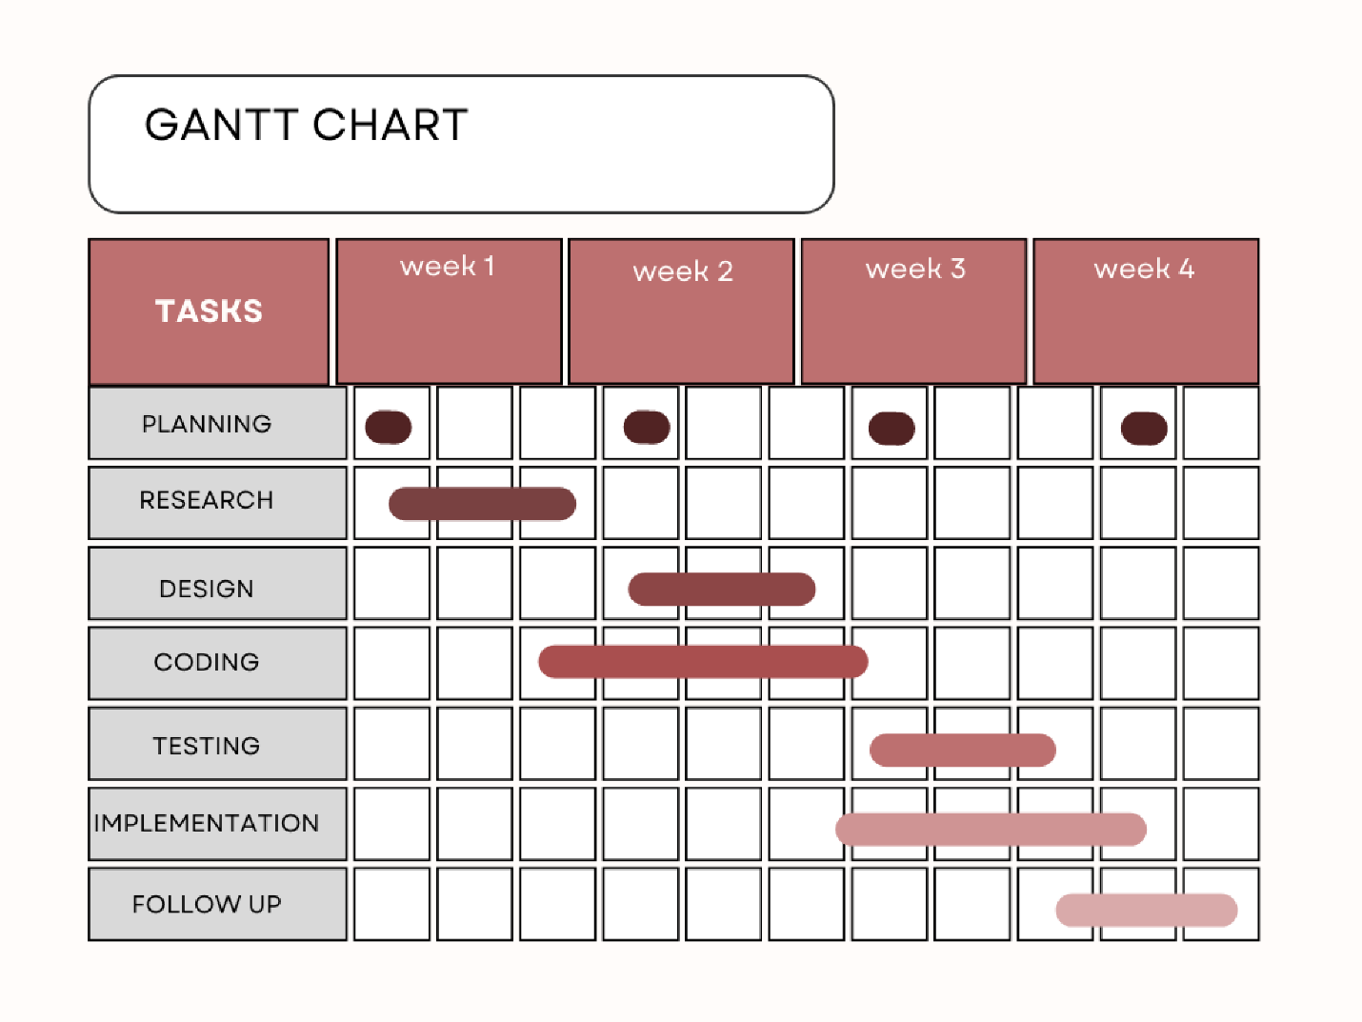

1. Huang, X., Zhang, L., & Yang, J. (2019). Investigating the influence of user experience on the continuous use intention of mobile instant messaging apps: An empirical study. International Journal of Human-Computer Studies, 128, 1-12.
2. Matschitsch, M., & Tscheligi, M. (2016). Privacy and security in instant messaging applications: A comparative study of WhatsApp, Threema, and Viber. In Proceedings of the 2016 ACM Conference on Computer Supported Cooperative Work and Social Computing (pp. 320-331).
3. Matsumoto, D., & Yoo, S. H. (2019). Facilitating intercultural communication through mobile messaging apps: A review and recommendations for future research. Journal of Cross-Cultural Psychology, 50(5), 604-623.
4. Namba, T., & Swar, B. (2019). Communicating with rich media in messaging apps: Influences on user experience and privacy concerns. Journal of Computer-Mediated Communication, 24(3), 105-120.